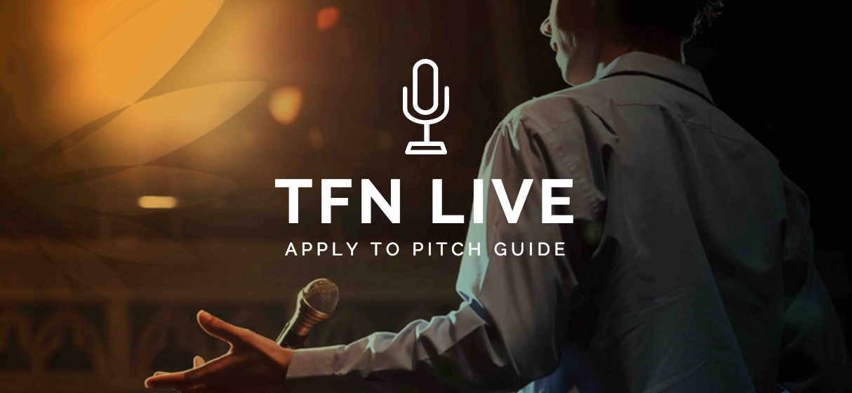

Overview

TFN partners with grassroots non-profits and early-stage social enterprises that have the potential to create positive change for individuals, communities and society over the long term.

Specifically, TFN supports organisations that aim to do one or more of the following:

- Address issues of social inequality in the areas of poverty, sickness or disadvantage
- Find a better solution to an underlying social problem
- Pilot innovative solutions to social issues, with the potential for expansion

Social issue areas that TFN supports include: homelessness, living with disability, mental health, education and employment, crime reduction, social and economic inclusion, social justice and wellbeing.

Core Criteria

- Grassroots organisations that would be defined as small to medium-sized with an average income of $1,000,000 pa or less over the last three years. In some circumstances we have discretion up to $1.5m but you should contact us in advance to discuss before making an application.
- There are no restrictions on the location or beneficiary groups that TFN will fund, including overseas programs. However, the organisation must be based in Australia and usually in the same State where event is being hosted.
- Each application must be endorsed by an advocate, who is willing to provide a statement of support on the application form. If the organisation is selected as a finalist, that advocate will speak briefly in support of the organisation at the event and make the first pledge of $300 or more.
- TFN supports applications from organisations for core funding, however, they must demonstrate clearly how this will enable them to deliver their work and how the impact of the funding will be assessed.
- Our primary focus is to partner with grassroots PBIs and registered charities, but we will consider applications from non-registered charities (social enterprises, aboriginal corporations, community associations, etc), as long as their constitutional primary purpose, and the program for which they are seeking funding, are clearly providing benevolent relief to identifiably disadvantaged members of the community. They will need to provide a copy of their constitution or other founding document when applying.
- TFN does not accept applications from programs that are primarily focused on the environment or animal welfare, except where there is a direct social outcome relating to our core social issue areas (outlined on previous page).
- TFN does not accept applications for advocacy campaigns, religious or political campaigns, crisis appeals, overseas aid, health research or applications from individuals.
- Organisations applying must have strong leadership and a deep understanding of their theory of change for communities.

Event specific criteria (TFN Live on 25 September 2019)

- Suitable organisations must be able to pitch for a project valued at a minimum of approx. $40,000+
- Organisations may support programs run in Australia or overseas but they must be registered charities in Australia.
- Organisations must strictly meet our ‘Early Years’ criteria and run programs that ensure the optimum level of care, education and welfare for children aged 0-5 and their families who may be experiencing disadvantage, homelessness, domestic violence, disability, illness, access to education, geographical barriers, refugee or migrants, aboriginal or Torres Strait Islander, linguistically diverse etc. If you have any concerns over the suitability of your program please contact us at info@thefundingnetwork.com.au

* Applications from organisations who do not meet these criteria will, unfortunately, not be considered. Please note TFN alumni are NOT eligible to pitch if they have already presented at a TFN event within the previous two years.

Selection Guidelines
Organisations applying are assessed by a selection panel using, broadly the following criteria:

Vision & Capacity
- Is it innovative?
- Is there a genuine need?
- Are the beneficiaries involved in the program or activity itself?
- Has there been sound field research and testing?
- Is the leadership team credible, including their management and governance?
Funding & Partnerships

- How will $15K impact the organisation?
- How will the funds be spent?
- Can they demonstrate a return on investment?
- Is the presenter passionate and compelling to an audience?
- Are there any current or potential collaborators to support scalability?
Impact & Sustainability

- How many people does this program or activity benefit?
- Does it empower community adoption?
- Is it sustainable?
- Is it scalable? To what extent?
- What are the risks?
- Is there a sound financial evaluation?
- Is the financial analysis convincing?
- Is the strategy long or short term?

For more information email: info@thefundingnetwork.com.au
To apply to pitch visit: www.thefundingnetwork.com.au/tfn-live/apply-to-pitch

